Below are the linux commands with screenshots of example:

1. pwd

The pwd command is a command line utility for printing the current working directory. It will print the full system path of the current working directory to standard output.

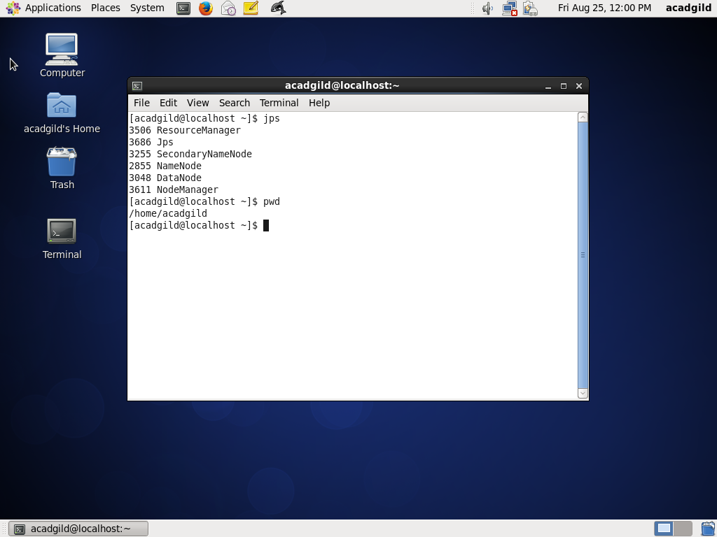

2. vi

vi editor is a full screen editor and has two modes of operation:Command mode commands which cause action to be taken on the file, and. Insertmode in which entered text is inserted into the file.

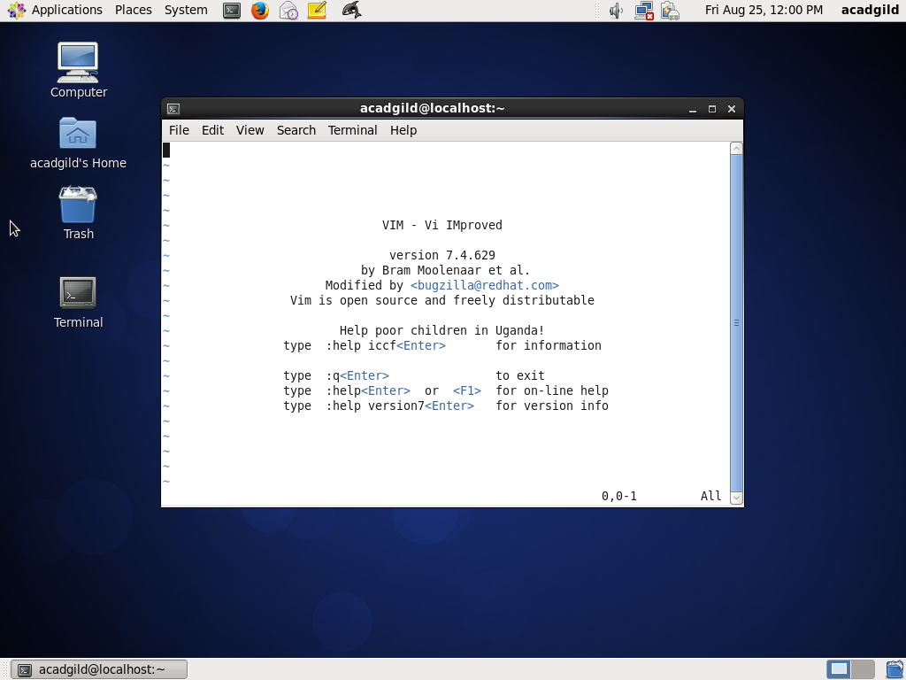

3. touch

The touch command updates the access and [modification](https://www.computerhope.com/jargon/m/modify.htm) times of each FILE to the current system time.

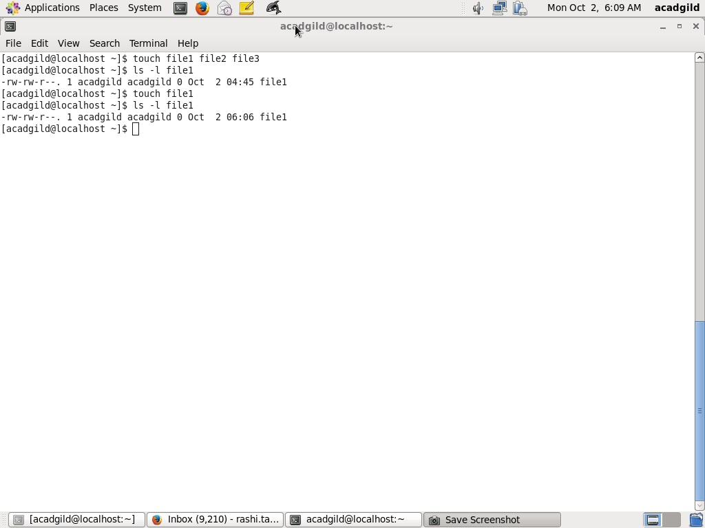

4. mkdir

The mkdir command is is used to create new directories.

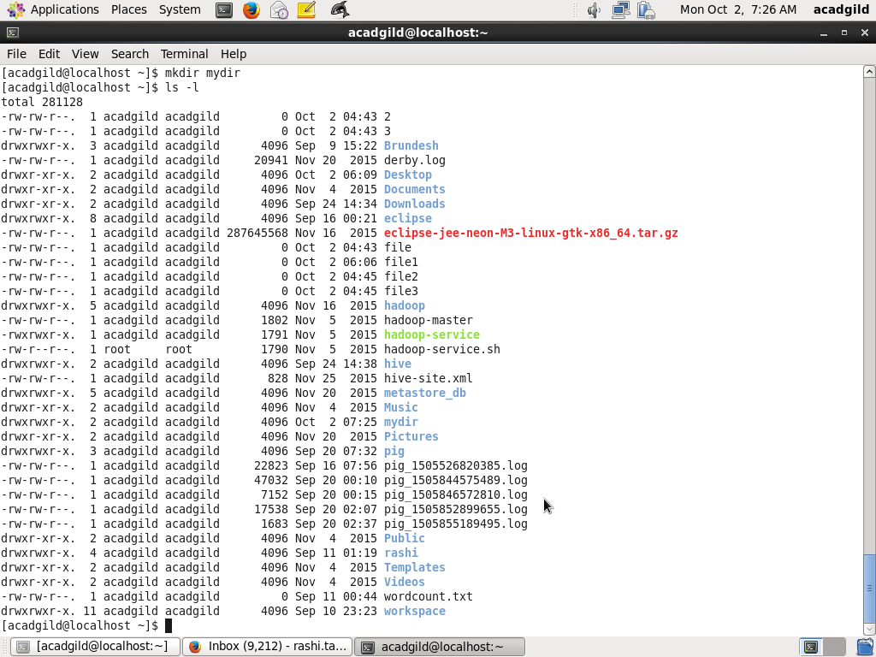

5. rm

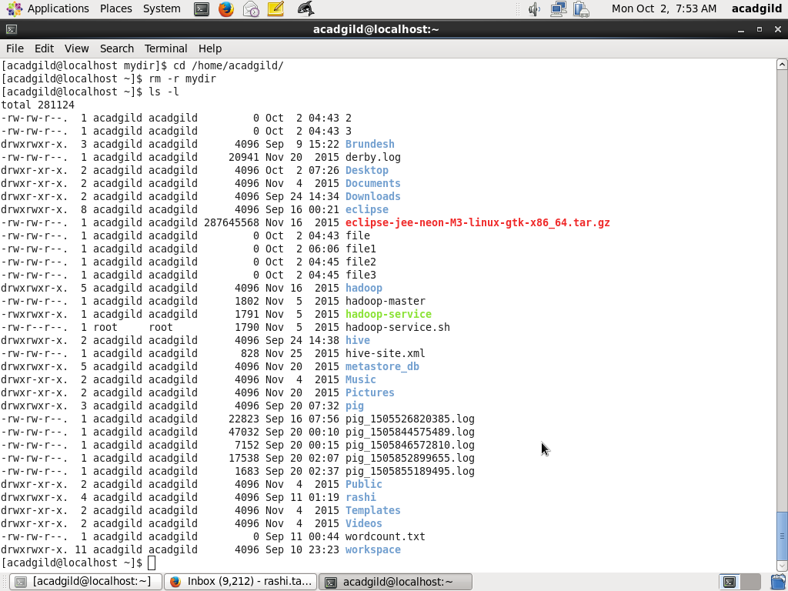

6. ls

Ls  lists directory contents of files and directories.

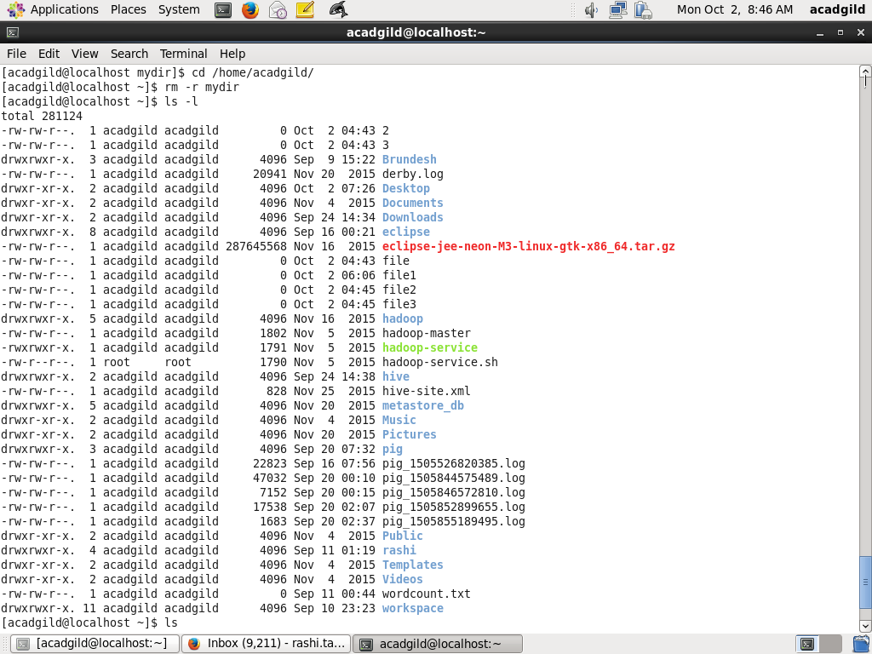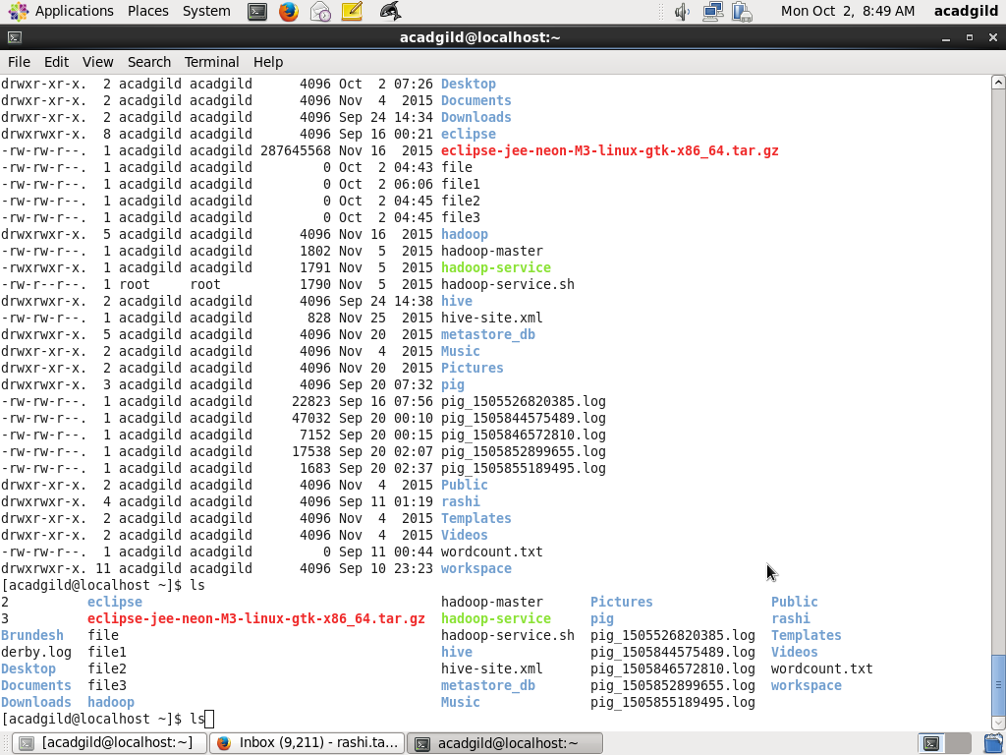

7. echo

Echo writes its arguments to standard output.

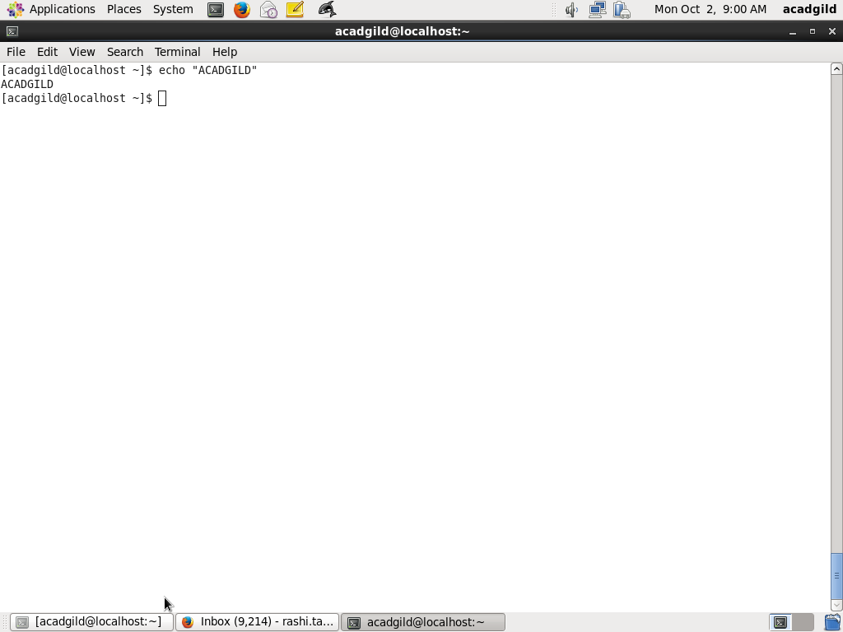

8. cat

cat command allows us to create single or multiple files, view contain of file, concatenate files and redirect output in terminal or files.

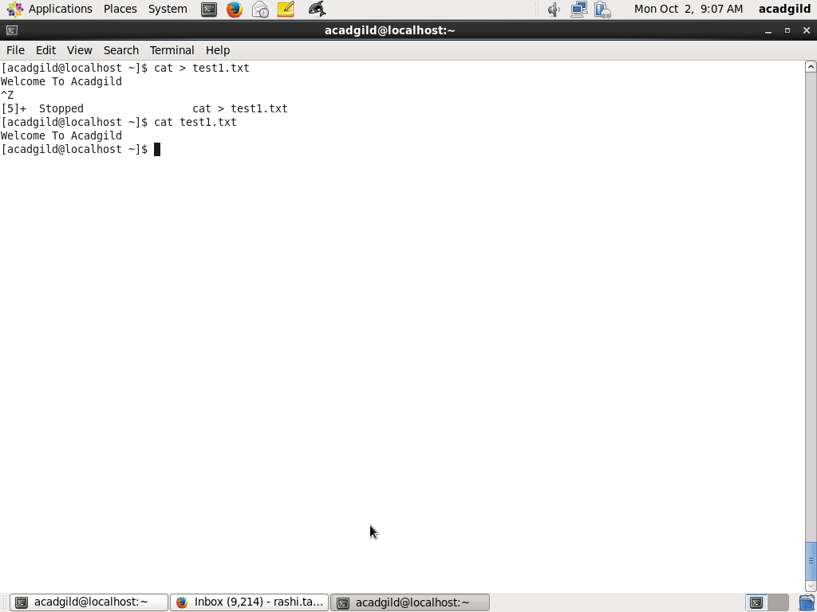

9. who

It provides:

* Time of last system boot
* List of users logged-in
* Current run level etc

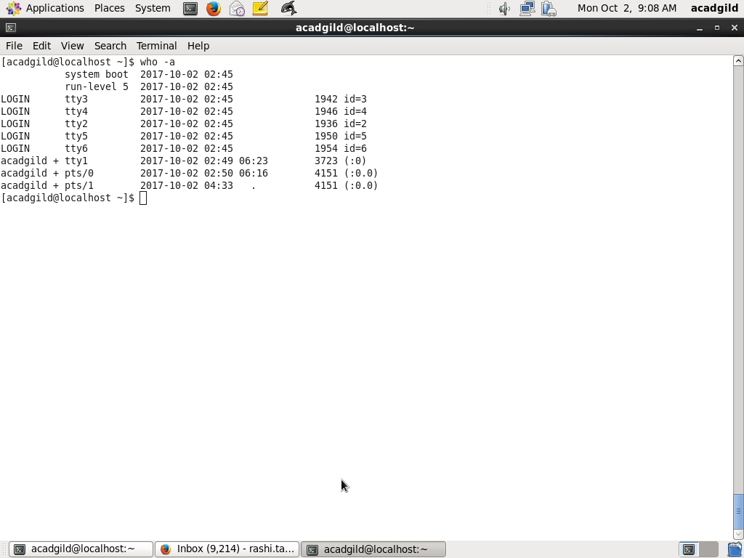

10. cd

The cd command is used to change the current directory (i.e., the directory in which the user is currently working)

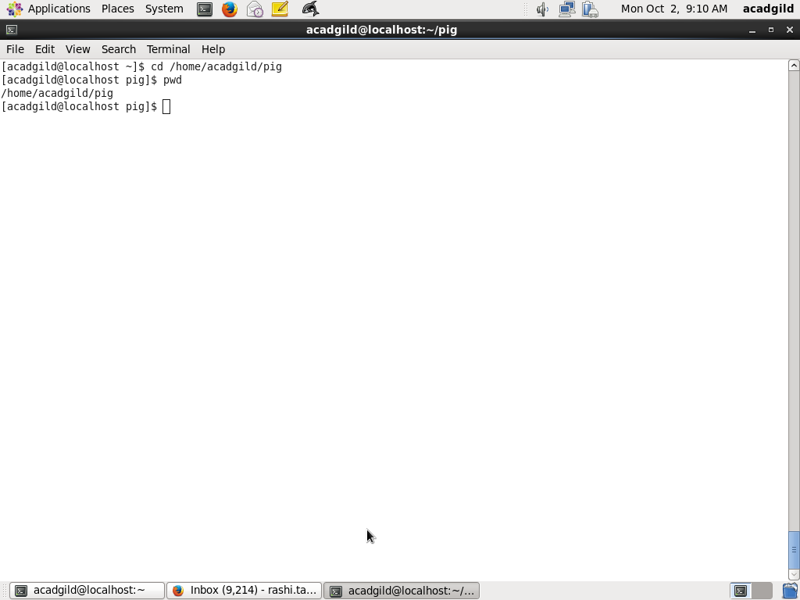

11. date

Date command displays date in several formats. It allows to set systems date and time.

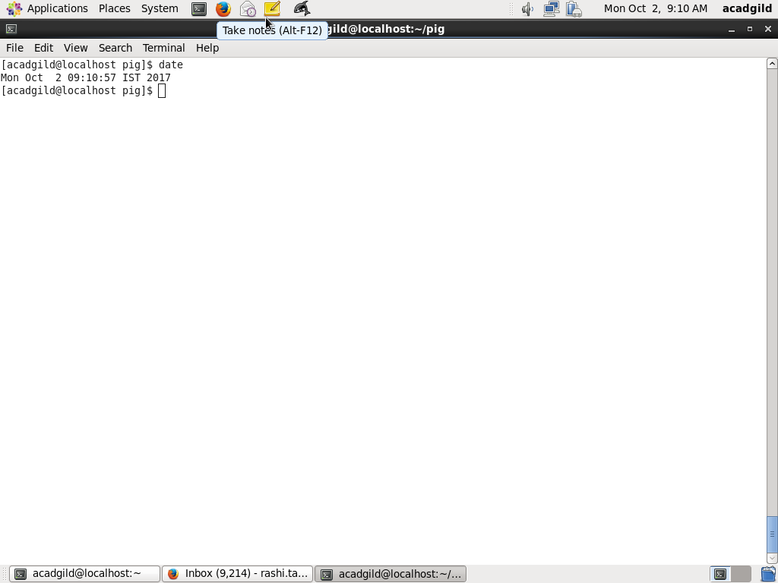

12. cal

The cal command is a command line utility for displaying a calendar in the terminal.

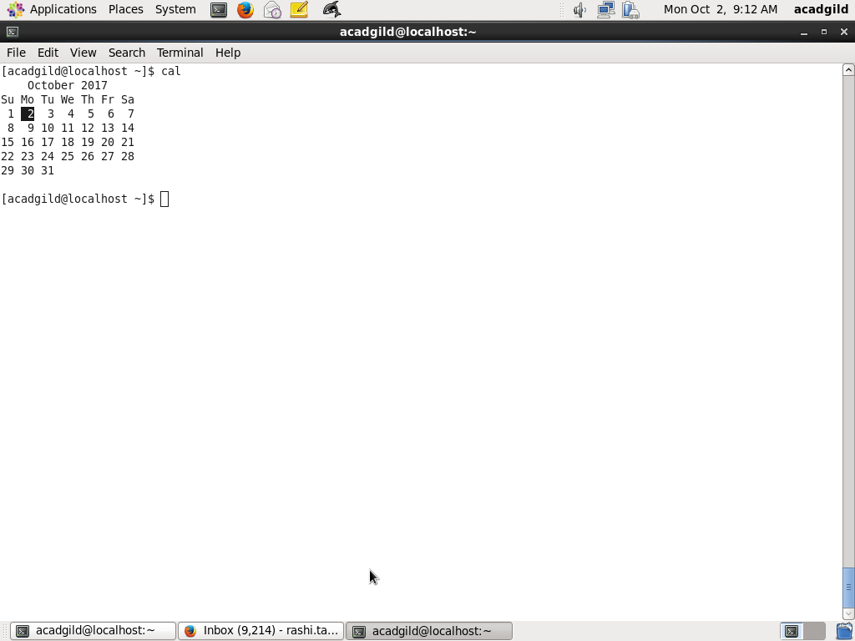

13. mv

The mv command is used to move or rename files.

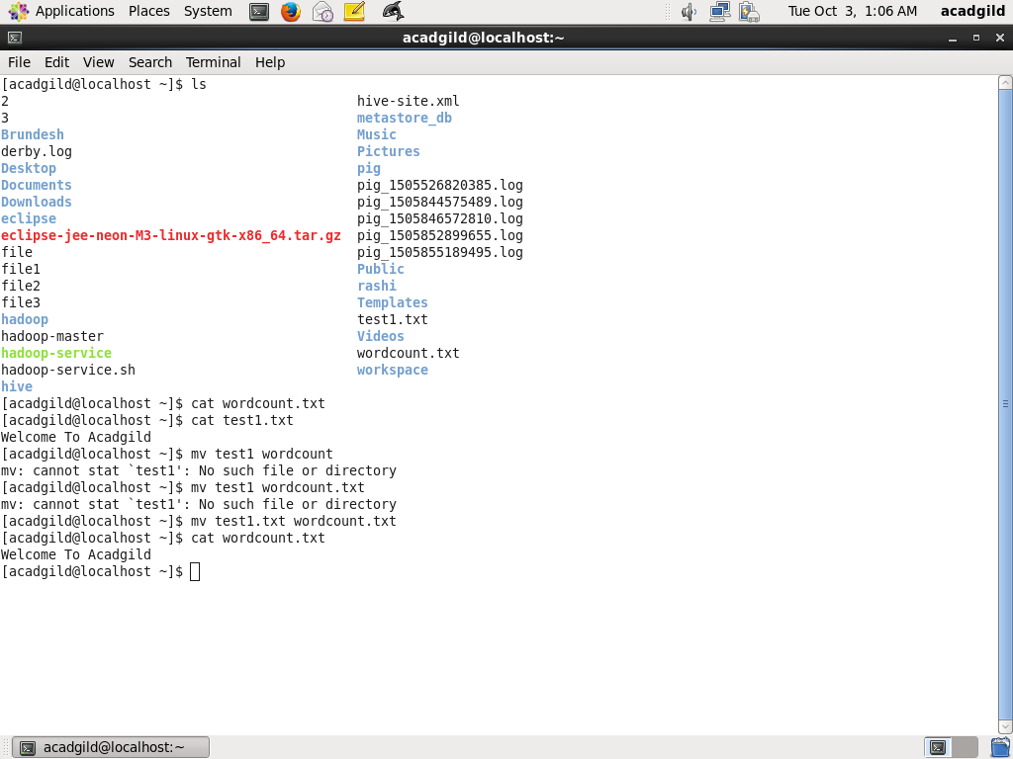

14. cp

 cp command to copy file from one location to other location.

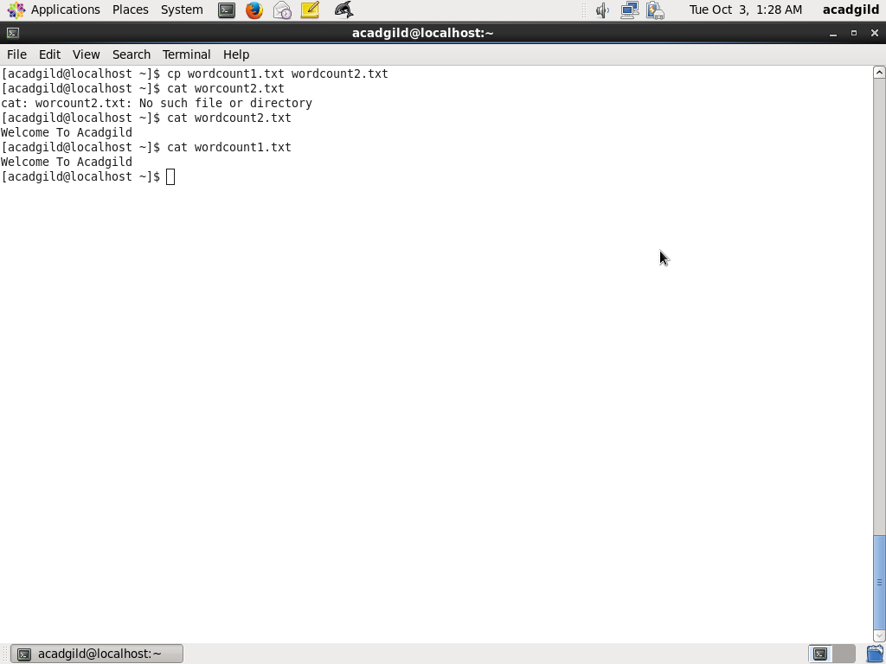

15. which

The command takes one or more arguments; for each of these arguments, it prints the full path of the executable to [stdout](https://en.wikipedia.org/wiki/Stdout" \o "Stdout) that would have been executed if this argument had been entered into the [shell](https://en.wikipedia.org/wiki/Unix_shell).

